The Eardley Family Clinic for Speech Language and Hearing
Client Information
Fall 2017
Main Office located in East Building Room 218
- If you cannot attend your therapy session, please call (314) 889-1407 or email your clinician. Due to supervisor and clinician schedules, absences cannot be rescheduled.
- Please do not eat, drink or smoke (this includes vaporizers) in the clinic areas. Keep children out of the clinic, especially therapy rooms, until your clinician comes to meet you outside the clinic.
- Siblings/other accompanying children should remain with parents at all times.
- The Clinic will be closed if Fontbonne’s campus is closed or on a snow schedule. In case of inclement weather, go to Fontbonne.edu or call the clinic office. Announcements for Fontbonne’s closure or snow schedule are made ONLY on:
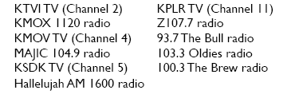

FALL SCHEDULE
 | Monday | Tuesday | Wednesday | Thursday
September | 04  11  18  25 | 05  12  19  26 | 06  13  20  27 | 07  14  21  28
October | 02  09  16  23  30 | 03  10  17  24  31 | 04  11  18  25 | 05  12  19  26
November | 06  13  20  27 | 07  14  21  28 | 01  08  15  22  29 | 02  09  16  23  30
December | 04 | 05 | 06 | 07

** Days in red indicate days when Fontbonne’s campus is closed for holidays

