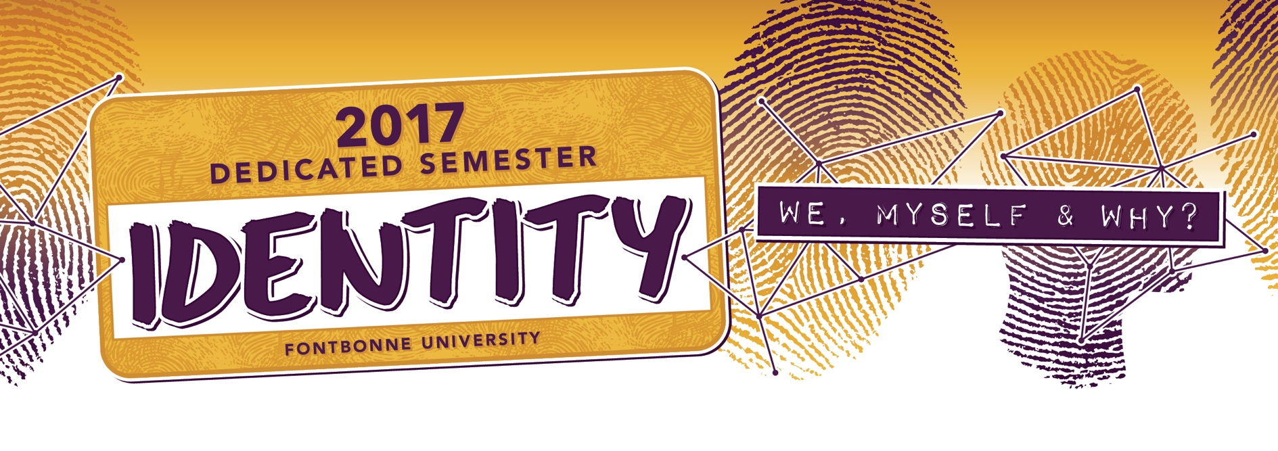

Who are you? Who are we together? Is your identity your own or do others co-construct it with you? Is your self stable or ever-changing? There are so many questions we can ask about our identities, but one thing we can know for sure is that identity matters. Our identities shape and are shaped by our experiences of the world, they influence the opportunities we have and the struggles we encounter, and they are situated in cultures, histories, belief systems, and power structures. We dedicate the Fall 2017 semester to the broad consideration of identity and identities. We invite you to find yourself, discover the other, and celebrate our identity as the community of Fontbonne University.

OUR TRANS FAMILY PHOTO EXHIBIT
August 25-September 22nd
Open during Fine Arts Gallery Hours – Fine Arts Gallery
Twenty-seven framed photographs of transgender people and their families.

CONVOCATION: THE SOCIAL NATURE OF IDENTITY: ME, MYSELF, AND WHY
August 30 – 10 a.m. – DSAC Gymnasium
Featured Speaker: Wayne Brekhus, Ph.D., Associate Professor of Sociology, University of Missouri- Columbia

COFFEE TALK AT THE WYDOWN HOUSE
September 1 – 11 a.m. – Wydown House
Please join the Pressimone’s for coffee, pastries, and conversation centered on an identity-themed topic. RSVP is required.

OPENING GALLERY TALK: OUR TRANS FAMILY PHOTO EXHIBIT
September 7 – 5 p.m. – 8 p.m. – Fine Arts Gallery
Featured Speakers: Jeff Pearcy and Meredith Watts, from the charitable organization “For Good” Photography, Inc.

SHOW-ME DEMOCRACY FILM
September 12 or 13 – 7PM – Library Lewis Room
In collaboration with the Peace and Justice committee, join us for a showing of the documentary “Show-Me Democracy” and a discussion to follow with Fontbonne Alum, Karina Arango and the film’s director.

TRANSCENDING GENDER: EXPERIENCING IDENTITIES ACROSS THE SPECTRUM
September 20 – 5 p.m.- 6:30 p.m. – Library Lewis Room
Perspectives from transgender and gender queer persons as well as parents of a transgender child.
Featured Panelists: Christa Cunningham, Rod Hall, Shannon Hall, Ro Kicker, Nick Stevens (FBU Alumnus)

FONTBONNE STUDENT IDENTITIES SPOTLIGHT: LATINO HISPANIC UNION
September 27 – 11 a.m. to 1 p.m. – Golden Meadow
Join students in the Latino Hispanic Union to learn more about their identities and experiences.

WOODROW WILSON GRANT SPEAKER: SAYU BHOJWANI
October 2 – TIME, LOCATION, & TOPIC TBD

CSJ IDENTITIES: TRIP TO THE MOTHERHOUSE
October 4 – TIME – Meet in the AMC
Take a tour and have dinner at Sisters of St. Joseph Carondelet Motherhouse. RSVP is required.

COFFEE TALK AT THE WYDOWN HOUSE
October 6 – 11 a.m. – Wydown House
Please join the Pressimone’s for coffee, pastries, and conversation centered on an identity-themed topic. RSVP is required.
FONTBONNE STUDENT IDENTITIES SPOTLIGHT: FONTBONNE LGBTQA ALLIANCE FOR RESPECT
AND EQUALITY
October 11 – 11 a.m. to 1 p.m. – Golden Meadow
Join students in FLARE to learn more about their identities and experiences.

EXPLORING ST. LOUIS’ IDENTITY: NEIGHBORHOODS TROLLEY TOUR
October 20 – 1 p.m.- 4 p.m. – Golden Meadow
Take a ride on a trolley through the St. Louis neighborhoods to learn about their rich history. RSVP is required.

SERVICE WITH THE CSJS
October 21 – 9 a.m.- 1 p.m. – Meet in the AMC
Service is a strong component of our Fontbonne identity. Join us for a morning of service with the CSJs. RSVP is required.

FONTBONNE STUDENT IDENTITIES SPOTLIGHT: COMING FROM A SMALL TOWN
October 23 – 11 a.m. to 1 p.m. – Golden Meadow
Join students from rural areas to learn more about their identities and experiences.

THE INTERSECTION OF EDUCATIONAL DISABILITIES/EXCEPTIONALITIES AND IDENTITY
October 25 – 8 p.m. – Library Lewis Room
Featured Panelists: Nancy Bonn- Winkler, School counselor for Gifted Education, Rockwood School District, Madeleine Grucza, Special Educator, and Emily Klein, Fontbonne Student
Host: Michael Barla, Ed.D., Assistant Professor of Education/Special Education, Fontbonne University

SOCIAL MEDIA AND IDENTITY
November 1 – 4 p.m. – DSAC Caf’
Learn about the impact social media has on your identity through a panel discussion and expo.

COFFEE TALK AT THE WYDOWN HOUSE
November 3 – 11 a.m. – Wydown House
Please join the Pressimone’s for coffee, pastries, and conversation centered on an identity-themed topic. RSVP is required.

OMICRON DELTA KAPPA PRESENTS THE BREAKFAST CLUB FILM AND DISCUSSION
November 10 – 7 p.m. – Library Lewis
Omicron Delta Kappa invites you to join them for a viewing of the movie The Breakfast Club and engage in a group discussion led by Kristen Norwood, Kevin Eiler, and Janelle Julian.

FONTBONNE STUDENT IDENTITIES SPOTLIGHT: INTERNATIONAL BAZAAR
November 14 – 11 a.m. to 1 p.m. – DSAC Gymnasium
Food, dance, and décor! Join our many international students to learn more about their identities and experiences.

MANDY HARVEY PERFORMANCE AND TALK
November 17 – 7 p.m. – DSAC Caf’
Mandy Harvey is a singer, songwriter and motivational speaker who happens to have an invisible disability. Mandy will perform her music while sharing her story of re-discovering herself after losing her hearing at the age of eighteen.

FONTBONNE STUDENT IDENTITIES SPOTLIGHT: BLACK STUDENT UNION
November 30 – 11 a.m. to 1 p.m. – Golden Meadow
Join students in the Black Student Union to learn more about their identities and experiences.

COFFEE TALK AT THE WYDOWN HOUSE
December 1 – 11 a.m. – Wydown House
Please join the Pressimone’s for coffee, pastries, and conversation centered on an identity-themed topic. RSVP is required.

THE VOICE OF DREAMER
December 7 – TIME, LOCATION, & DESCRIPTION TBD
