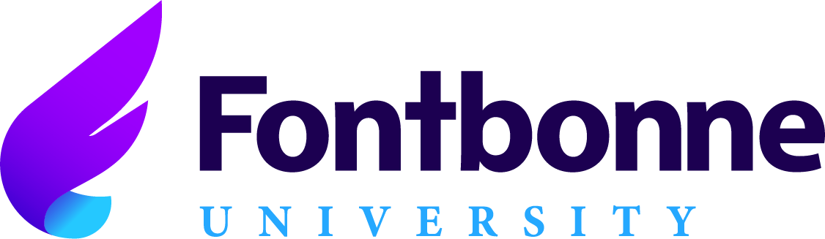

Myths About At Risk Families

LEARNING OBJECTIVES

What do you know about at-risk families? Be prepared to have your myths busted! We will explore identification of, assumptions about, collaboration with, and empowerment of families at-risk in our communities and schools.

As a result of this activity, participants will be able to:

- Identify indicators that a family may be “at risk”:
    - Eliminating assumptions about at risk families
    - Respecting at risk families
    - Knowing their history
    - At risk families and language/speech development

- Collaborate with at risk families:
    - Communication: build trust, listen, using non-judgmental statements, language barriers (asl, spanish, dialect)
    - Balancing being a mandated reporter with caring for students (being upfront)

- Learn strategies to empower at risk families:
    - Giving power back to the family
    - Balancing support with self care (you can’t pour from an empty cup)
    - Planning together for future

